**SYSTEM TO CATEGORIZE AN OBJECT WITHIN AN RGB IMAGE**

**Digital Image Processing**

By

Elupula Kranthi Kumar

**TABLE OF CONTENTS:**

INTRODUCTION.............................................................................................................................

PROJECT DESCRIPTION................................................................................................................

Filters and examples.....................................................................................................................

Size of vector obtained from CNN..............................................................................................

Convolution and pooling layer....................................................................................................

Number of connected layers.......................................................................................................

System loss function and justification..........................................................................................

Activation Functions and reasons ...............................................................................................

Pooling Functions and reasons.....................................................................................................

Stop criteria on the training procedure ........................................................................................

EXPERIMENTS AND RESULTS.....................................................................................................

PROS AND CONS ............................................................................................................................

FURTHER IMPROVEMENTS…........................................................................................................

**GROUP MEMBERS AND ASSOCIATED TASK**

Our goal was to keep our code simple while focusing on enhancing the algorithmic time complexity for an efficient solution. We broke down the tasks into manageable steps and assigned responsibilities to team members. To ensure smooth coordination, we conducted regular meetings to monitor individual progress, address challenges, and quickly resolve any.

**INTRODUCTION**

Convolutional Neural Networks (CNNs) are pivotal in image processing due to their distinct architecture, specifically tailored to automatically learn hierarchical features from images. This unique capability allows CNNs to grasp both low-level details like edges and textures and high-level features such as object shapes. The spatial hierarchies captured by CNNs are particularly valuable for tasks like object recognition and image segmentation, where understanding the arrangement of features is essential.

A fundamental strength of CNNs lies in their parameter sharing mechanism, enabling the same set of filters to be applied across different spatial locations. This promotes translation invariance, ensuring consistent pattern recognition throughout the entire image and proving crucial for tasks like image recognition. The adaptability of CNNs to variations in scale, rotation, and orientation makes them versatile for handling diverse image appearances, a vital characteristic in real-world applications.

CNNs serve as effective feature extractors by automatically learning relevant features from raw pixel data through convolutional and pooling layers. This reduces the need for manual feature engineering and makes CNNs well-suited for tasks involving complex and intricate underlying patterns. Additionally, their robustness, adaptability, and state-of-the-art performance across various image processing tasks solidify the importance of CNNs in advancing the field of computer vision.

**Top of Form**

**Bottom of Form**

**PROJECT DESCRIPTION**

In this project we have created a system to categorize an object within an RGB image.

**STEP BY STEP IMPLEMENTATION OF THE PROJECT**

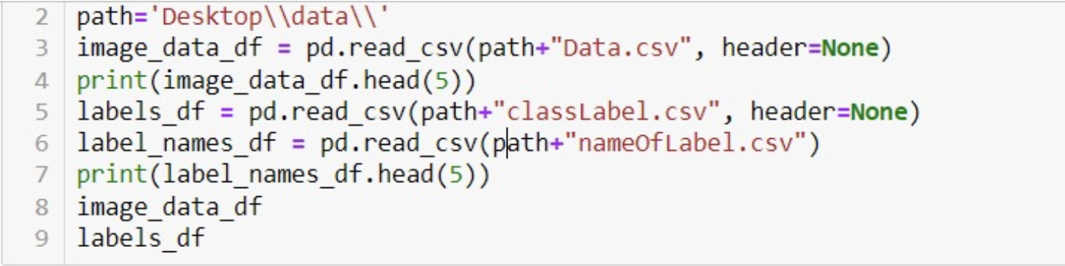

We have leveraged the Jupyter Notesbook module to upload the test and train files The method read_csv() is used to read the content from the files. Checked the duplicate of the rows

**Preprocessing of the image**

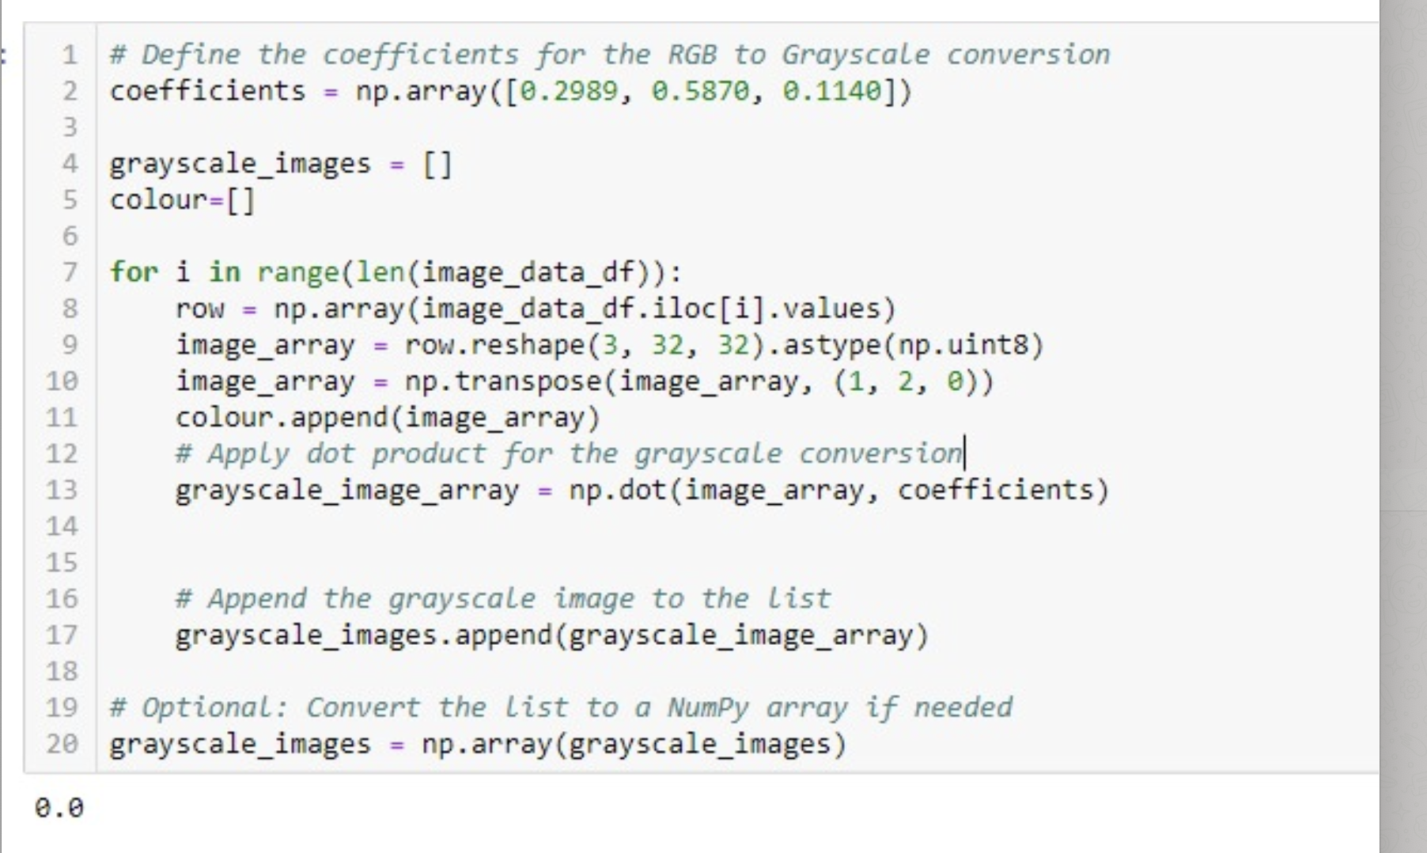

Converting RGB images to grayscale is a preprocessing technique that can simplify the model and enhance its efficiency. Grayscale images have just one channel, reducing the data's dimensionality compared to the three channels in RGB images. This reduction not only decreases the computational demands on the model but also streamlines the feature set to intensity variations, which are often sufficient for pattern recognition. By converting to grayscale, the model can focus on structural and textural information, which is particularly useful when color does not provide additional distinguishing information for the classification task.

his conversion using a weighted sum of the RGB channels, which reflects the different levels of sensitivity that the human eye has to these primary colors. The weights [0.2989, 0.5870, 0.1140] correspond to the contribution of each color channel to the perceived luminance, with green being the most significant, followed by red, and then blue. This transformation is applied to each image in the dataset, creating a list of grayscale images. These images are then stored in a NumPy array, offering a more compact and efficient representation for the subsequent stages of the neural network training process.

**FILTERS AND EXAMPLES**

**Introduction to Image Filtering**

In the realm of digital image processing, the pivotal role of image filtering cannot be overstated. This technique involves the strategic modification of pixel values based on specific operations, serving as a cornerstone for feature enhancement, noise reduction, and the extraction of crucial information from images. Among the plethora of available filters, Gaussian, Laplacian, Sobel, and Prewitt filters stand out for their diverse applications and unique functionalities.

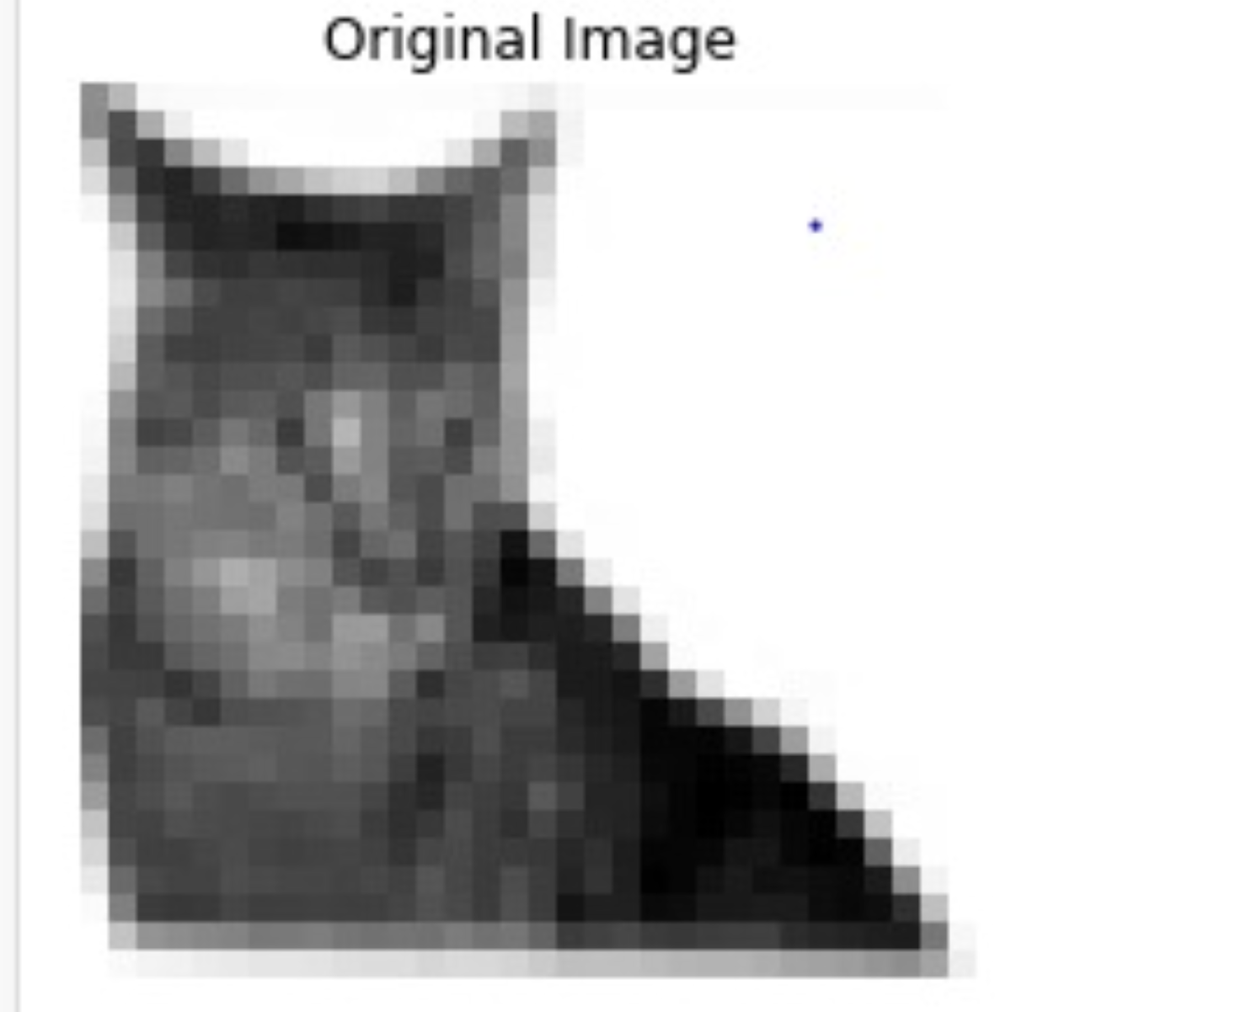

**Gaussian Filter**

The Gaussian filter, renowned for its efficacy in blurring images, achieves this through a convolution operation employing a Gaussian kernel. This filter is instrumental in noise reduction and conferring a smoother appearance to images. Characterized by a bell-shaped curve, its strength is modulated by the standard deviation parameter. Primarily employed for smoothing and noise reduction.

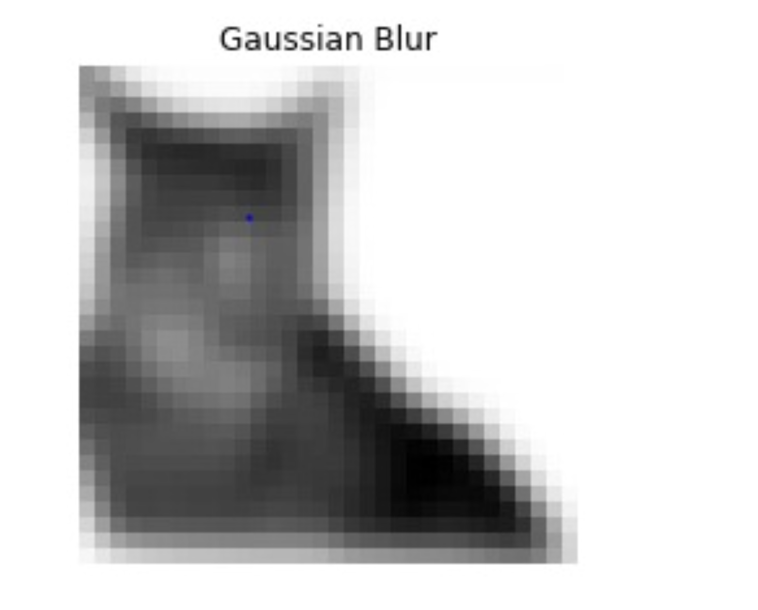

**Laplacian Filter**

The Laplacian filter emerges as a key tool for edge detection by accentuating regions of abrupt intensity changes within an image. Its primary function is to highlight edges and other perceptible discontinuities, making it invaluable for identifying crucial features. Emphasizes regions of rapid intensity change for effective edge detection.

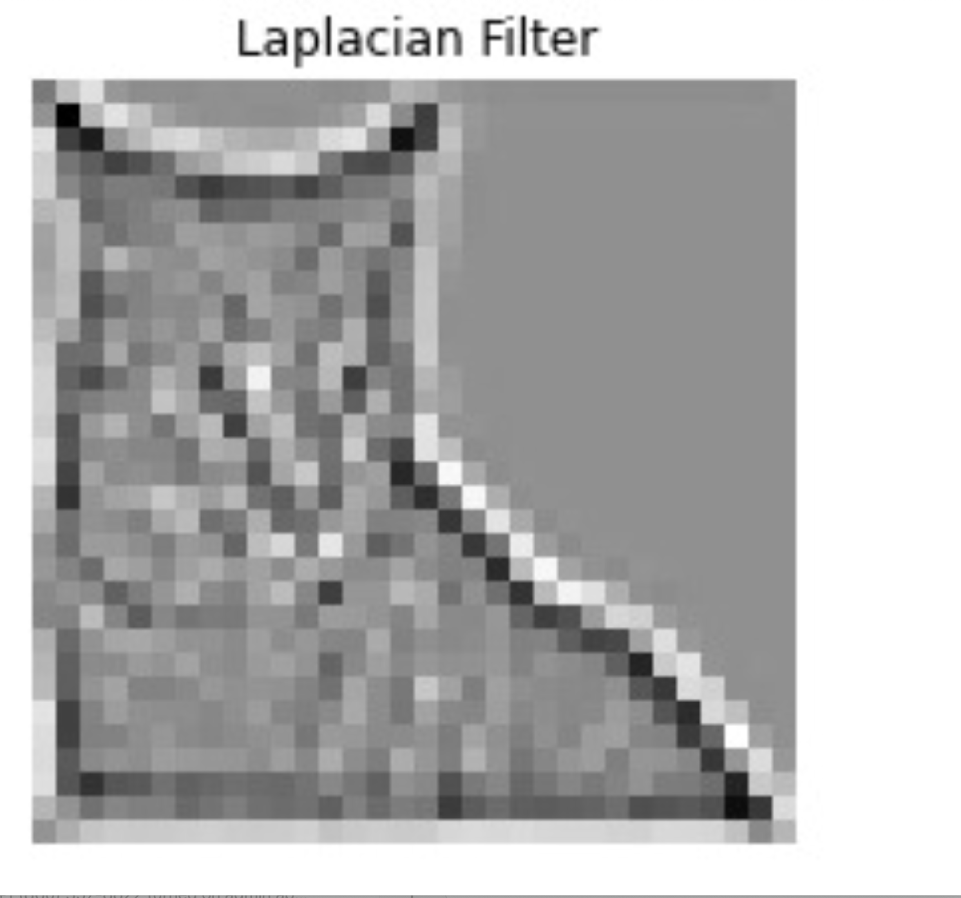

**Sobel Filter**

As a gradient-based filter, the Sobel filter takes center stage in edge detection by computing the gradient magnitude of an image. It employs two 3x3 kernels—one for horizontal changes and the other for vertical changes—to effectively identify edges in both directions.

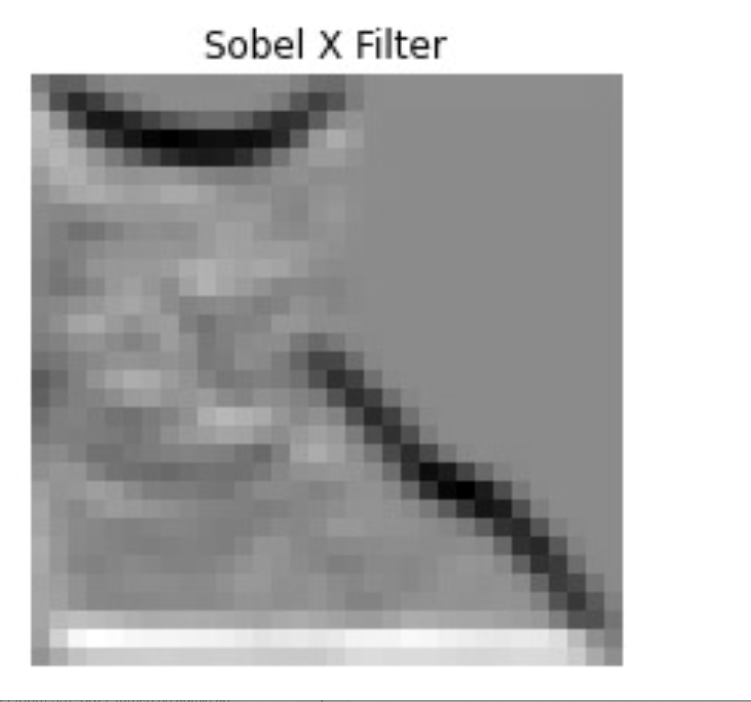 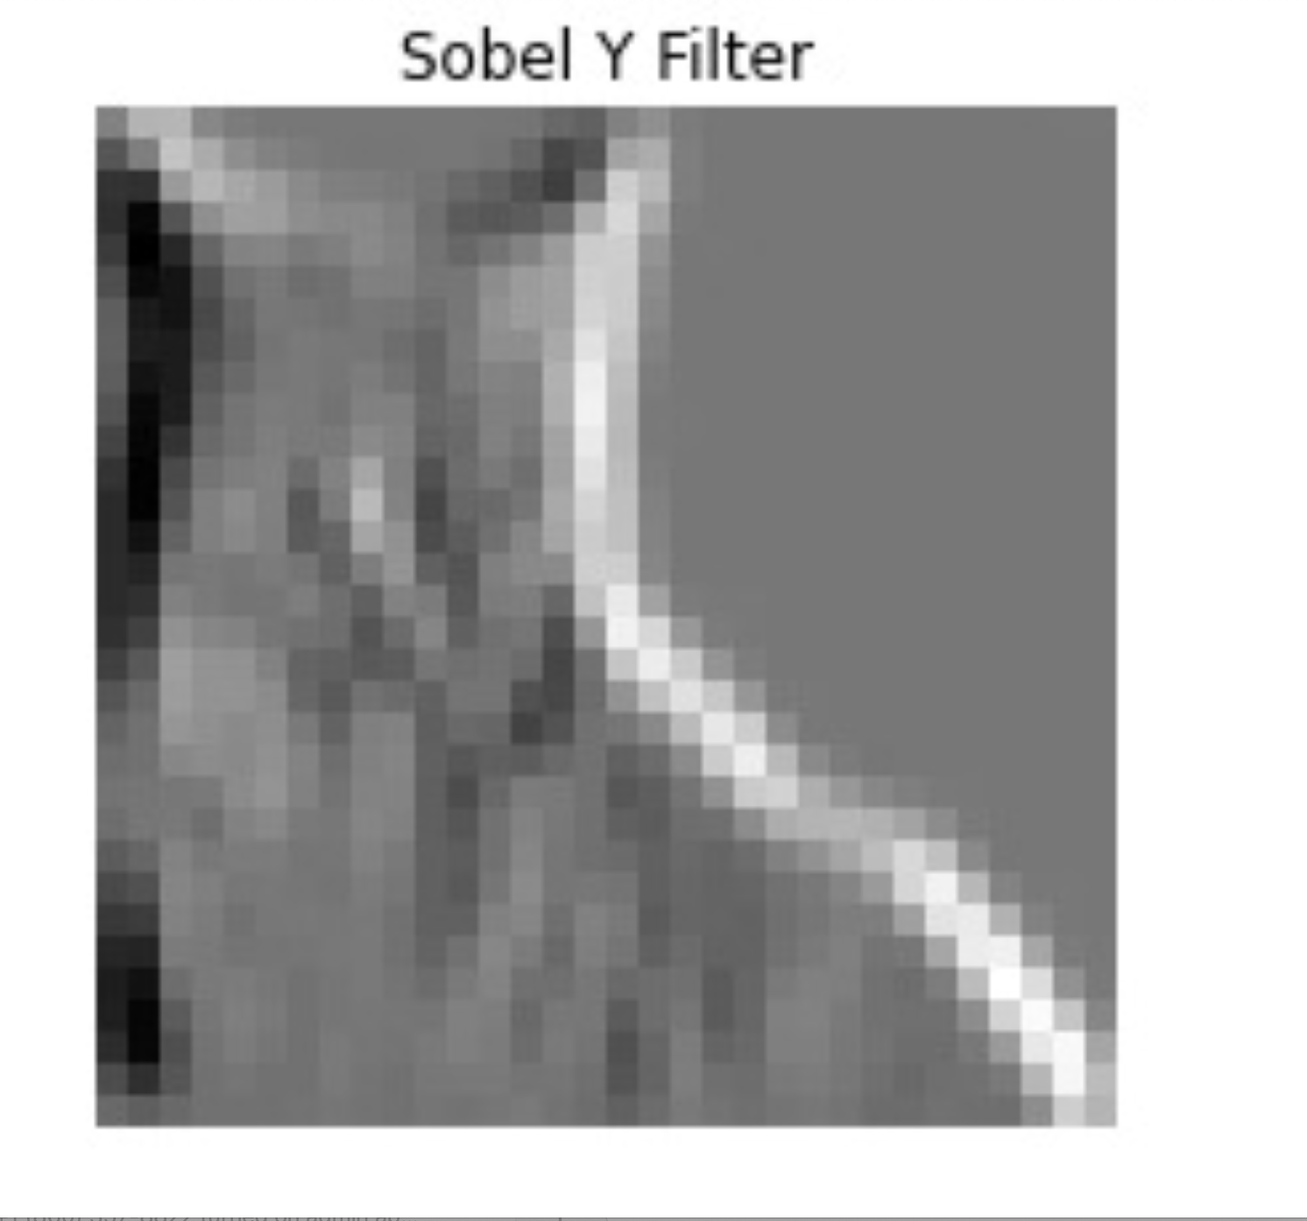

**Prewitt Filter**

Similar to the Sobel filter, the Prewitt filter adopts a gradient-based approach for edge detection. Comprising two 3x3 convolution kernels, it calculates horizontal and vertical gradients to effectively identify edges.

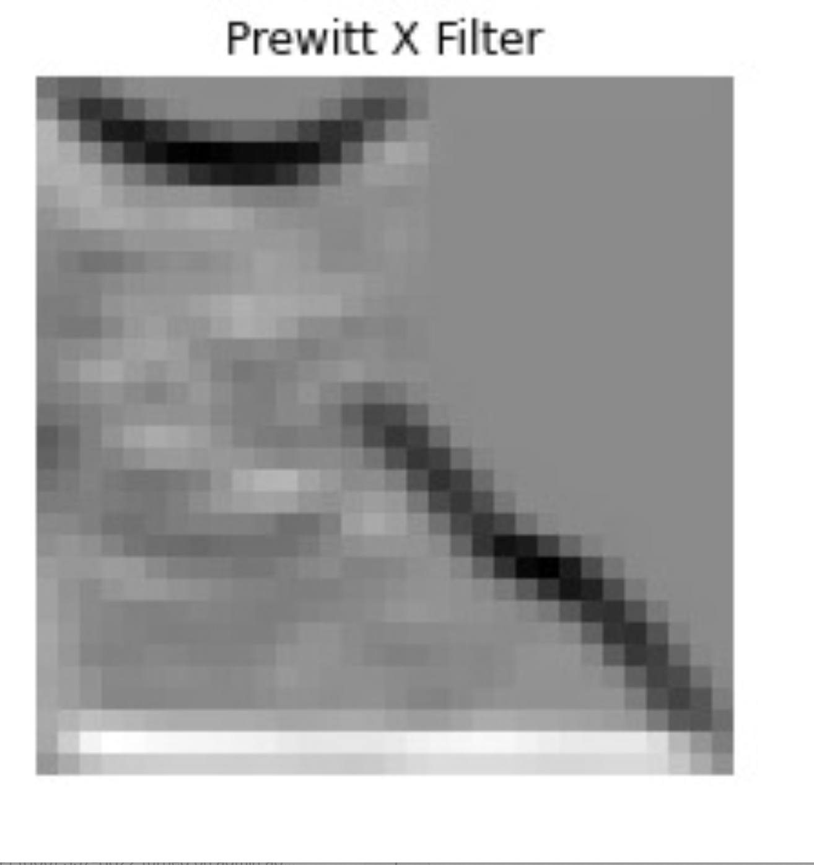 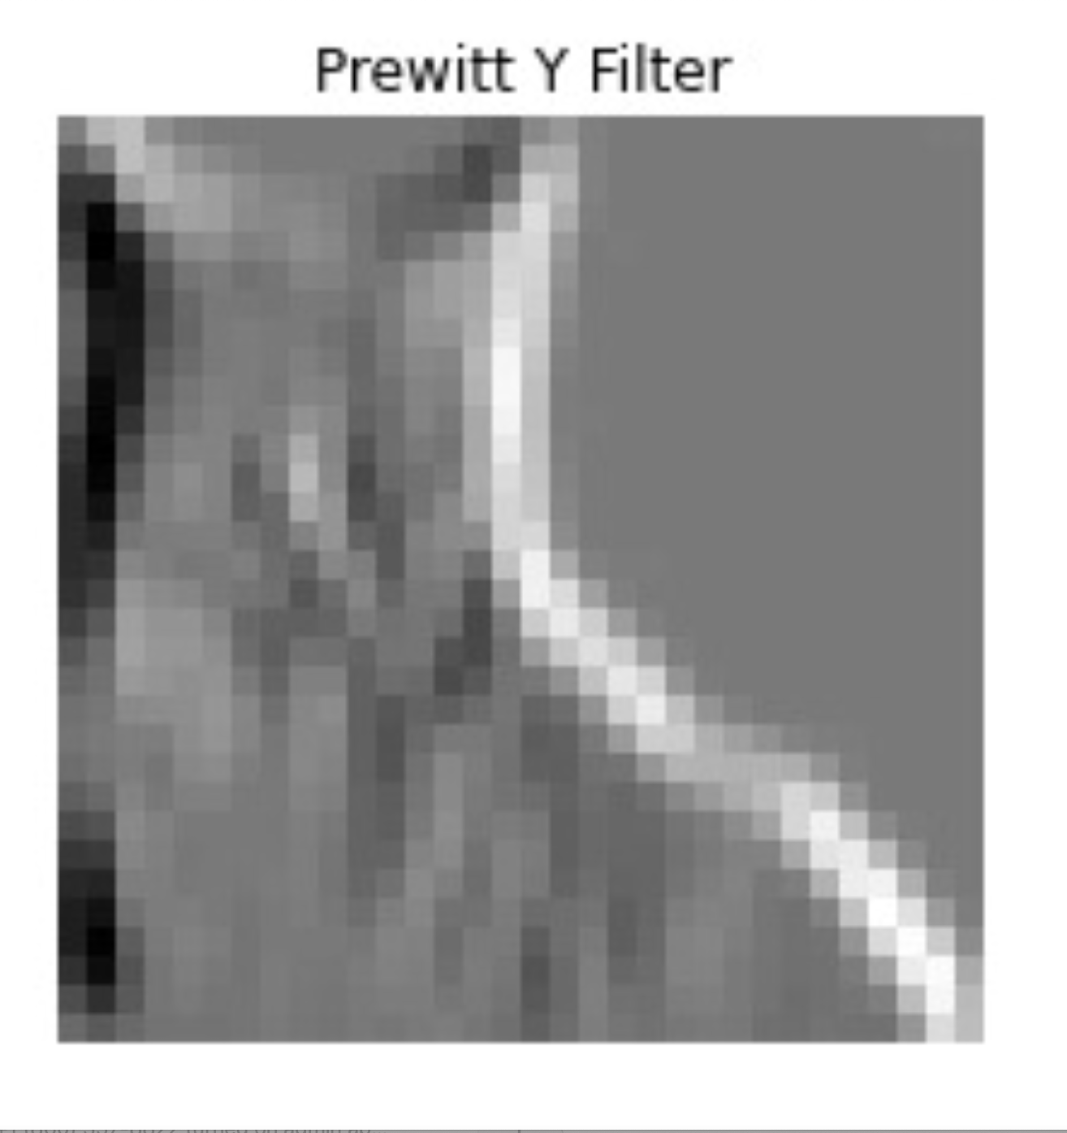

**THE SIZE OF THE FEATURE VECTOR OBTAINED FROM CNN**

In the architecture of a Convolutional Neural Network (CNN), each layer plays a critical role in transforming and extracting features from input images. The network starts with an input layer designed for grayscale images of size 32x32 pixels. As the image passes through the Conv2D layers, it undergoes a series of convolutions with filters that modify its dimensions. The first convolutional layer uses 32 filters of size 3x3, reducing the image dimensions to 30x30, and subsequent convolutional layers with 64 filters further process the data. Interspersed MaxPooling2D layers down sample the feature maps, halving the dimensions each time. After the final pooling layer, the output has a reduced size of 5x5 pixels with 64 feature maps, reflecting the extracted features.

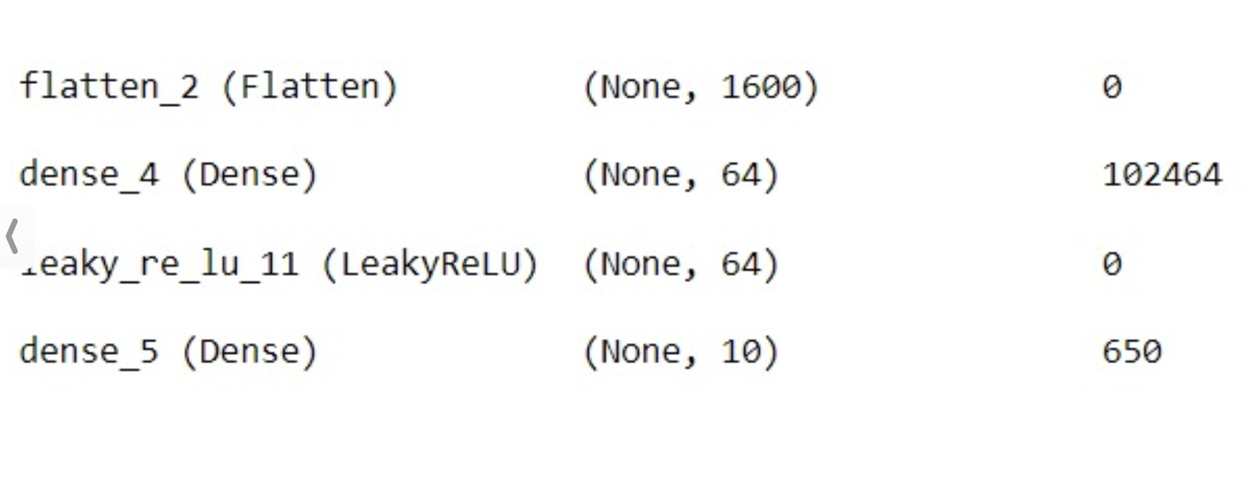

The feature extraction journey culminates in the Flatten layer, where the 3D output is transformed into a 1D feature vector. This flattening is pivotal as it reshapes the pooled feature maps into a format suitable for the dense layers of the network, transitioning from spatial feature representation to a linear array. The size of this flattened vector, essential for subsequent classification tasks, is computed by multiplying the dimensions of the final pooling layer's output, resulting in a vector of 1600 elements (5x5x64). This process demonstrates the CNN's ability to condense complex spatial information from images into a comprehensive feature set, crucial for effective image analysis and classification. The size of the feature vector obtained from this CNN, just before the first Dense layer, is 1600. This means the first Dense layer with 64 neurons will receive an input vector of size 1600.

**THE NUMBER OF CONVOLUTION AND POOLING LAYERS FOR FEATURE EXTRACTION**

1

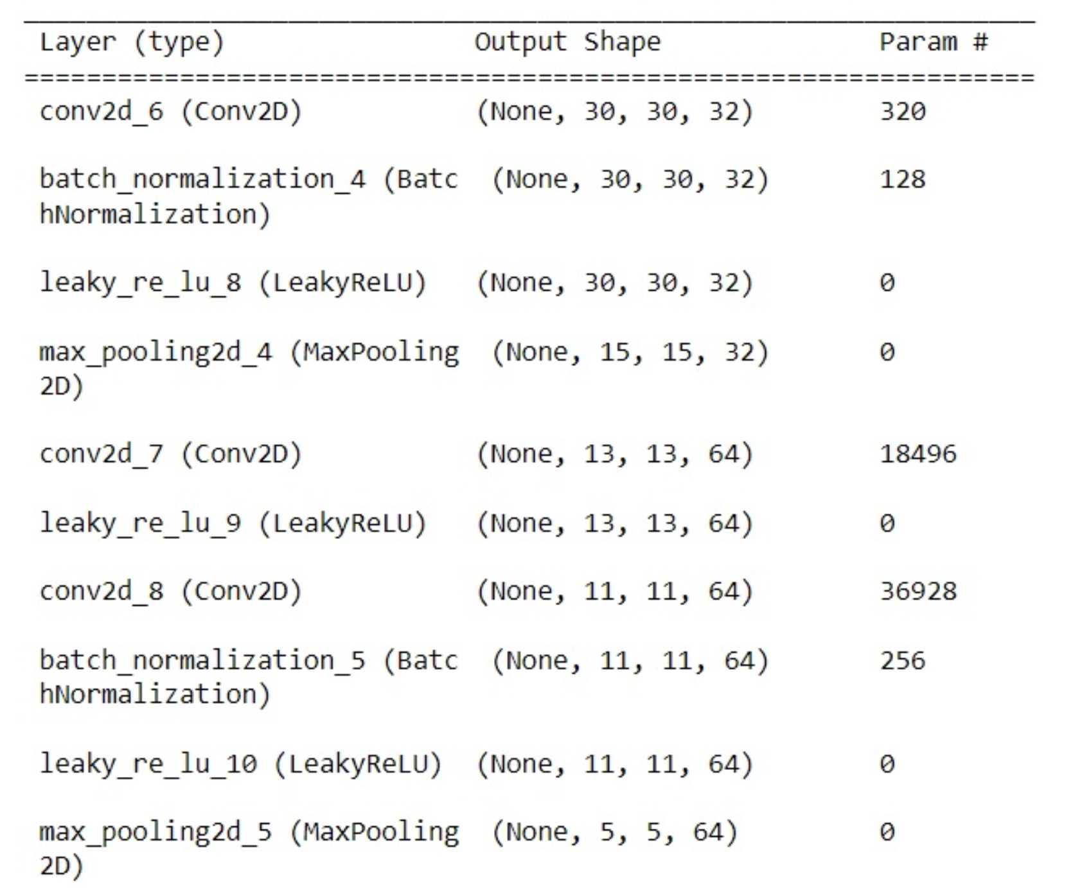

configuration of convolutional and pooling layers forms the essence of the CNN, enabling effective image processing for classification tasks.

**THE NUMBER OF FULL CONNECTED LAYERS FOR CLASSIFICATION**

Neural Network (CNN) model, the network architecture incorporates two essential fully connected layers, identifiable as `Dense` layers within the Sequential model. These layers play a pivotal role in the final stages of the neural network, where the abstracted and processed information from the previous layers is further refined and prepared for the ultimate task of classification. The first of these fully connected layers, containing 64 units, acts as a crucial intermediate processing stage. Here, the network synthesizes and transforms the features extracted by the convolutional and pooling layers into a more complex and abstract representation. This transformation is key in distilling and interpreting the spatial and feature-based information garnered from the input images. Following this, the second fully connected layer, comprising 10 units, corresponds directly to the classification aspect of the model.

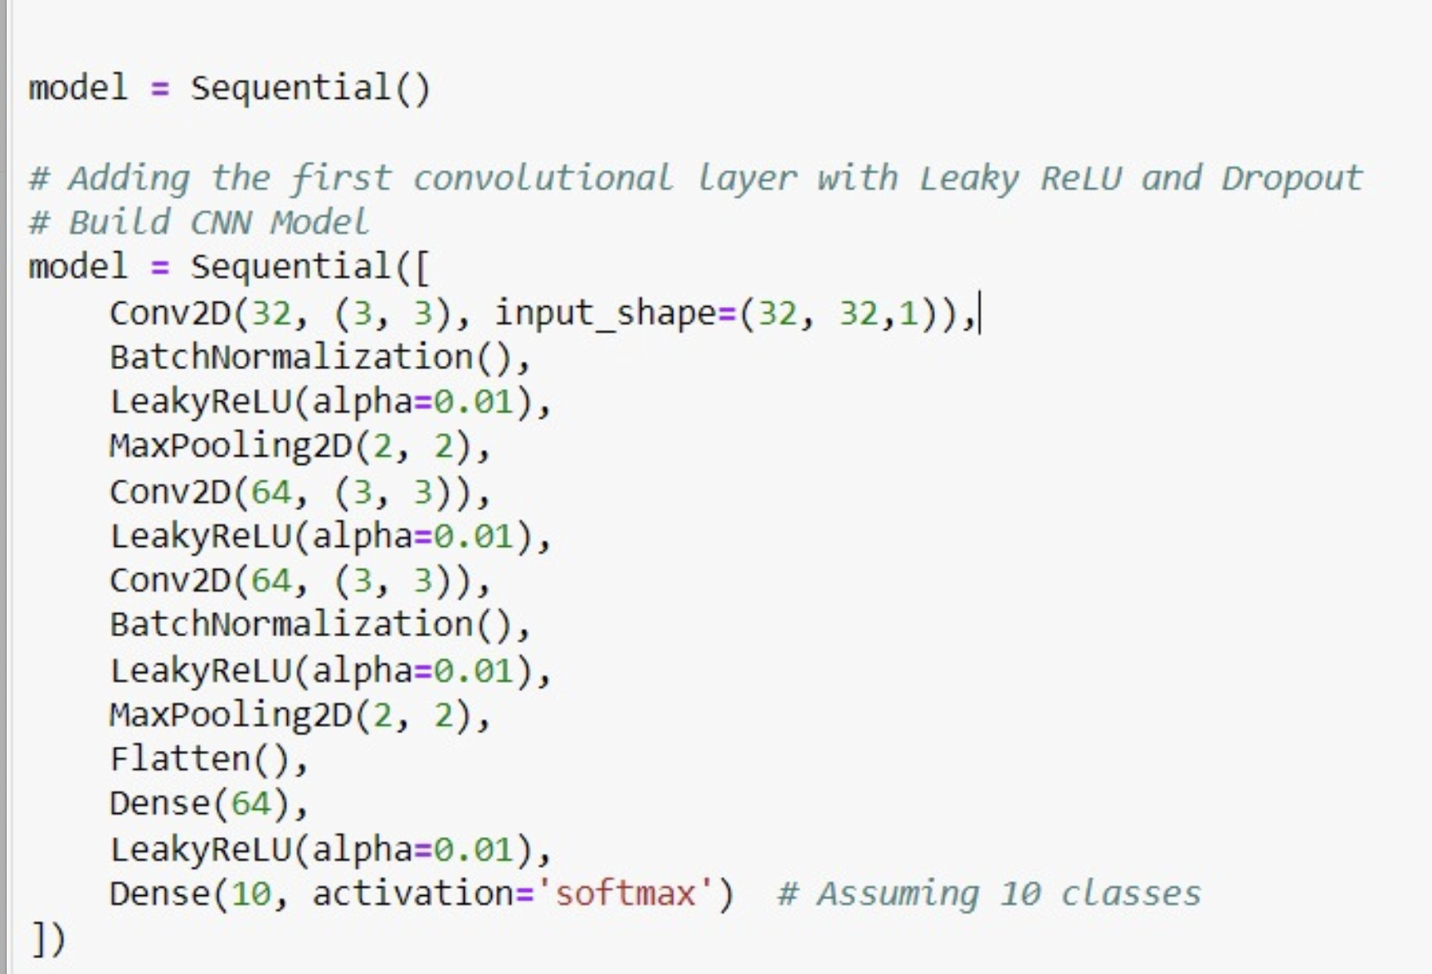

This layer's primary function is to map the processed and synthesized feature data onto the 10 distinct class categories, outputting the probability distribution across these classes. This final layer essentially serves as the decision-making component of the network, determining the class to which the input image most likely belongs based on the learned features.

**THE SYSTEM LOSS FUNCTION**

The two key elements are utilized in the model compilation and training phases: the sparse_categorical_crossentropy loss function and the softmax activation function in the output layer.

**Sparse Categorical Crossentropy Loss Function:**

The sparse_categorical_crossentropy loss function is particularly tailored for multi-class classification problems where each input belongs exclusively to one class out of many. Unlike standard categorical crossentropy that requires one-hot encoded labels, this "sparse" version efficiently handles labels provided as simple integers, each representing a specific class. This approach significantly streamlines the labeling process by eliminating the need for one-hot encoding. Essentially, sparse_categorical_crossentropy computes the crossentropy loss, measuring the discrepancy between the model's predicted probability distribution and the actual label distribution. Its design makes it especially suitable for situations involving multiple distinct classes, where each data instance is associated with only one class label

**Softmax Activation Function in the Output Layer:**

In multi-class classification models, like our 10-class scenario, the softmax function in the output layer is crucial. It transforms the model's raw prediction values (logits) into a set of probabilities that collectively add up to 1, offering a clear probabilistic interpretation of the outputs. Each output node's value represents the model's confidence that the input corresponds to a specific class. The class with the highest probability is typically selected as the model's final prediction. When used alongside the sparse_categorical_crossentropy loss function, softmax creates an effective system for predicting probabilities of different classes and accurately assessing these predictions against the actual labels.

Sparse_categorical_crossentropy is used for its suitability in multi-class classification tasks with integer labels, and softmax is employed in the output layer to interpret the neural network's logits as probabilities, facilitating a clear and probabilistic approach to classification.

**THE ACTIVATION FUNCTIONS**

In fine-tuning our neural network, we experimented with two activation functions: ReLU (Rectified Linear Unit) and Leaky ReLU, to identify which was more effective for our model. ReLU is favored in many neural network applications due to its computational simplicity and efficiency. However, it has a known limitation, often referred to as the 'dying ReLU' problem. This issue arises when neurons become inactive, outputting zero for negative input values, and thus cease to play any role in the network's learning process.

To address this, we considered Leaky ReLU, a variation of ReLU that allows a small gradient (proportional to the input) for negative input values. The introduction of this small gradient by Leaky ReLU helps in keeping all neurons active and involved in the learning process, regardless of their input values. This could potentially resolve the inactivity problem associated with standard ReLU.

During our comparative study of ReLU and Leaky ReLU, we focused on evaluating their suitability for our model, taking into account our network architecture and dataset specifics. Interestingly, we found that our model was not significantly affected by the dying ReLU issue. However, we observed that Leaky ReLU consistently outperformed ReLU in terms of accuracy. Given these findings and considering the superior performance of Leaky ReLU, we have decided to implement Leaky ReLU in both the input and hidden layers of our network.

In your neural network model designed for multi-class classification, the softmax function plays a crucial role in the output layer. It transforms the model's raw output values, or logits, into a normalized probability distribution. Each output corresponds to the model's estimated probability that the input belongs to one of the multiple classes (ten in your case). The softmax output, which sums up to 1, allows for an easy interpretation of the most probable class. This function, in conjunction with the `sparse_categorical_crossentropy` loss function, effectively enables the model to predict class probabilities and improve its accuracy through training.

**THE POOLING FUNCTIONS**

Max pooling, commonly implemented after convolutional layers in Convolutional Neural Networks (CNNs), serves to optimize feature processing and efficiency. Our technique involves a small window, typically 2x2, moving across the feature map to select the maximum value in each window area, effectively reducing the size of the feature map by half. This reduction highlights key features, enhances computational efficiency, and introduces translational invariance, making the network robust to minor shifts in the input images. Additionally, max pooling helps in reducing overfitting by lowering the model's complexity, thereby improving its ability to generalize to new data. These benefits make max pooling a crucial component in CNN architectures, especially for image-related tasks.

**THE STOP CRITERIA ON THE TRAINING PROCEDURE**

An "epoch" represents a full pass through the training dataset during model training, adjusting parameters like weights and biases based on calculated errors. To combat overfitting, I've implemented one stopping criteria: which is only epochs. We have opted against implementing early stopping in our model training process, primarily because our dataset is limited, and we want to avoid the overhead of validation in each epoch.

This approach aims to balance effective learning and prevention of overfitting. It ensures the model achieves optimal performance by stopping, safeguarding its accuracy on unseen data.

**EXPERIMENTS AND RESULTS**

**THE REASONS OF DETERMINING THE LEARNING**

1 Learning rate:

During the development of our model, we ran several experiments with different learning rates. The learning rate determines how quickly the model learns from the data. We tried various values and carefully compared their performance. After multiple rounds of testing and evaluation, we discovered that a learning rate of 0.001 struck the right balance for our specific task.

This learning rate of 0.001 allowed our model to learn effectively and converge to a good solution without running into issues that can arise with overly fast or slow learning rates. It played a crucial role in optimizing the performance of our neural network for the given problem

**HOW LONG THE TRAINING PROCEDURE**

**Epochs:**

I experimented with different numbers of epochs: 5, 10, and 15. Among these options, I observed that training the model for 17,18 and 20 epochs yielded the best results. In the other cases (20 - 25 and over epochs), I noticed signs of overfitting, where the model was learning the training data too well but not generalizing effectively to new data. We have finally decided

**THE ACCURACY OF THE SYSTEM**

During its training phase, the neural network model demonstrated a notable ability to learn, with accuracy steadily climbing from about 32.17% to 96.23% by the final epoch. The recorded test accuracy stands at 57.17%, acknowledging that the accuracy is relatively lower due to the limited size of the provided dataset. It's important to note that with a larger dataset, the accuracy has the potential to increase significantly.

Note: the accuracy have been fluctuating depending on initial epochs and training .

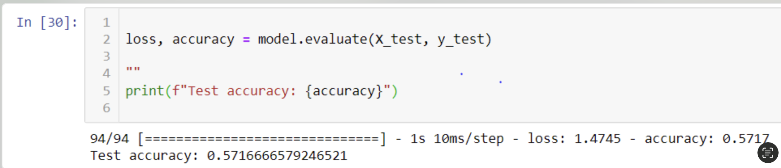

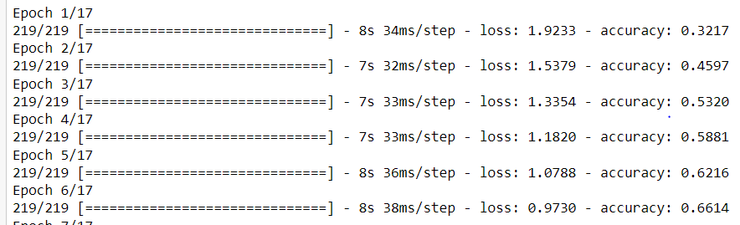

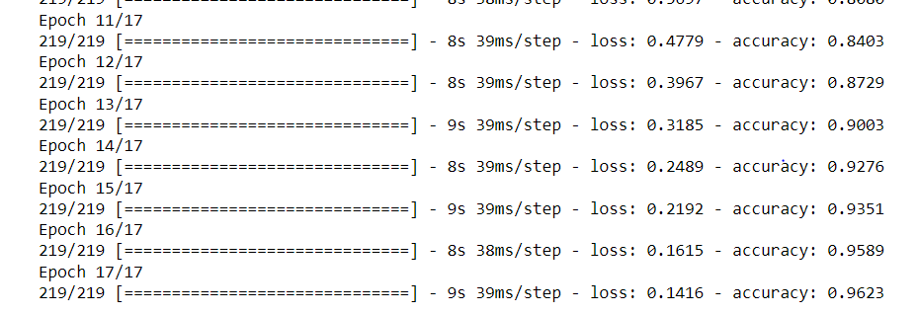

**PROS**

1. Robust Feature Extraction: The use of multiple convolutional and pooling layers in a CNN is excellent for extracting complex features from images. These layers can identify various patterns, edges, and textures, which are crucial for accurate image classification.

2. Dimensionality Reduction: The pooling layers reduce the spatial dimensions of the feature maps, making the network computationally more efficient. This reduction is beneficial in handling high-dimensional image data.

3. Flexibility in Architecture: The model's design, including the number of layers and neurons, offers flexibility to be tailored according to the specific requirements of the dataset.

4. Generalization Capability: A well-designed CNN, especially with appropriate dropout layers and regularization techniques, can generalize well to new, unseen data, reducing the risk of overfitting.

5. Automated Feature Engineering: Unlike traditional machine learning techniques, CNNs automatically detect the important features without the need for manual feature extraction.

**CONS**

1. Computational Complexity: Despite the reduction in dimensionality, CNNs can still be computationally intensive, especially with deep architectures and large datasets.

2. Risk of Overfitting: If not properly regularized or if trained with insufficient data, the model can overfit to the training data, leading to poor performance on unseen data.

3. Data Dependency: The effectiveness of a CNN heavily relies on the quantity and quality of the training data. Inadequate or biased training data can significantly affect the model’s performance.

4. Model Interpretability: CNNs, like many deep learning models, often act as black boxes, making it challenging to interpret how exactly the model is making its decisions.

5. Training Time: Depending on the complexity of the architecture and the size of the dataset, training a CNN can be time-consuming.

**FURTHER IMPROVEMENTS**

To address the model's overfitting and improve its generalization, a multifaceted approach is recommended. Data augmentation can introduce a broader spectrum of features for the model to learn, reducing its sensitivity to variations in new data. Regularization methods, such as L1, L2, and dropout, can prevent the model from becoming overly complex and too tailored to the training dataset. Hyperparameter tuning and exploring advanced neural network architectures may uncover more efficient structures and parameter configurations that enhance the model's performance. Techniques like learning rate schedulers, ensemble methods, and k-fold cross-validation further contribute to the robustness of the model.

Additionally, transfer learning can be particularly effective when dealing with limited datasets by leveraging knowledge from pre-trained models. Normalizing input features ensures consistent training dynamics, while acquiring more diverse data can fill in gaps in the model's understanding of the problem space. A thorough error analysis could also reveal specific weaknesses in the model, providing targeted opportunities for improvement. These strategies collectively aim to refine the model's ability to perform well across varied datasets, making it more reliable for practical applications.Bottom of Form